VPC TASK 2
- Create one VPC, with 1 public subnet and 1 private subnet.
- Go to aws console log in
- Search vpc and go to vpc (virtual private cloud)
- Create vpc give the name and select the cidr range from <ipadress>/16 to /28
- After creating go to the create subnets create one subnet and private subnet by providing the cidr block range according to the cidr range
- The private and public subnets are created.
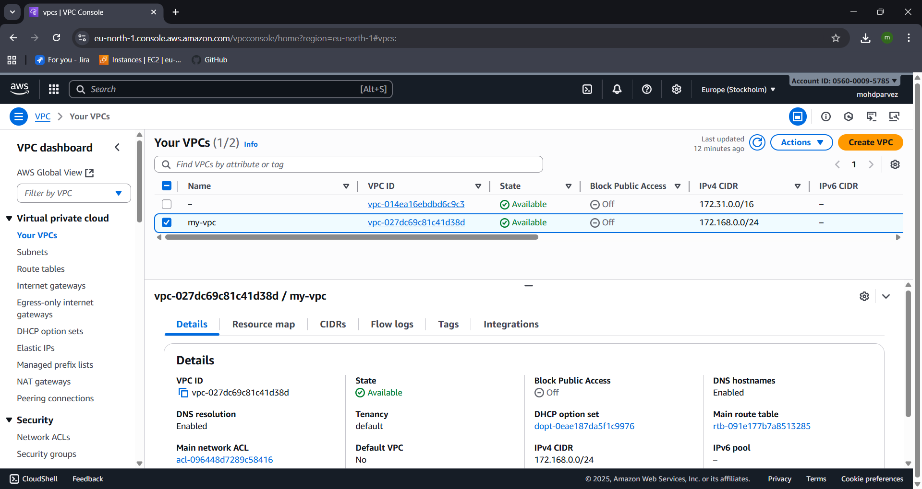
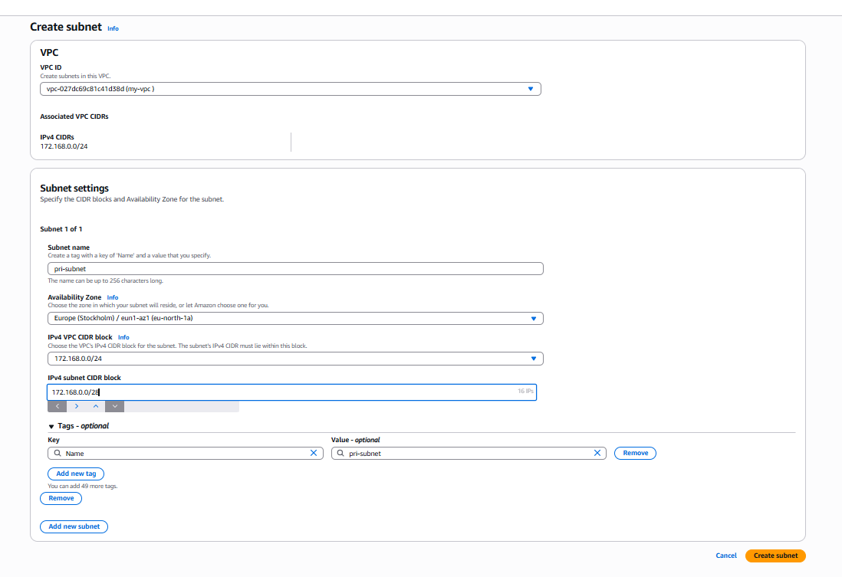
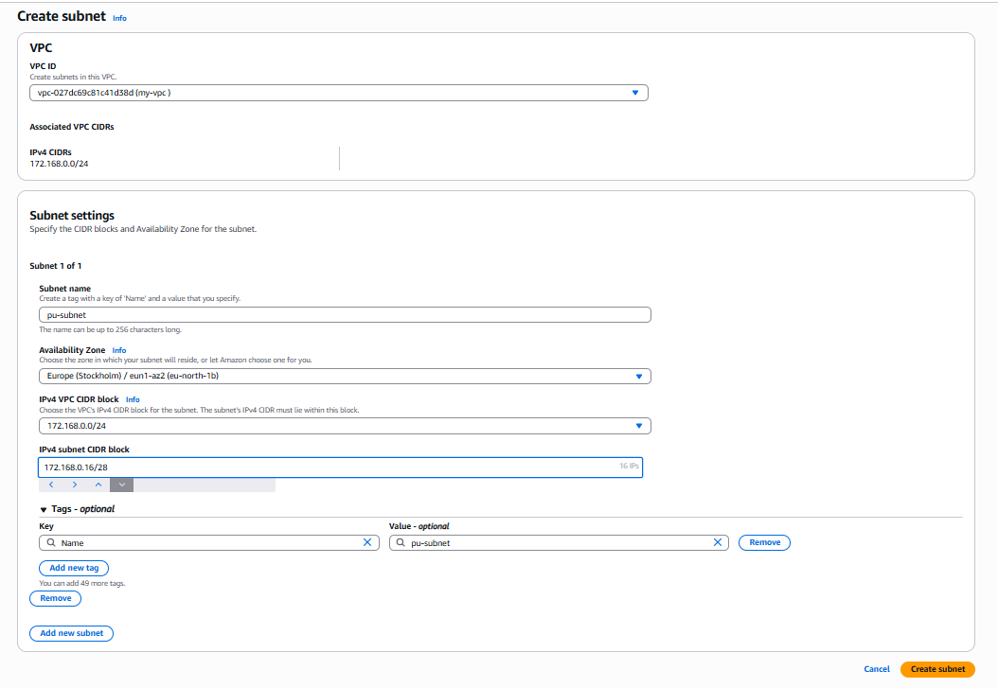
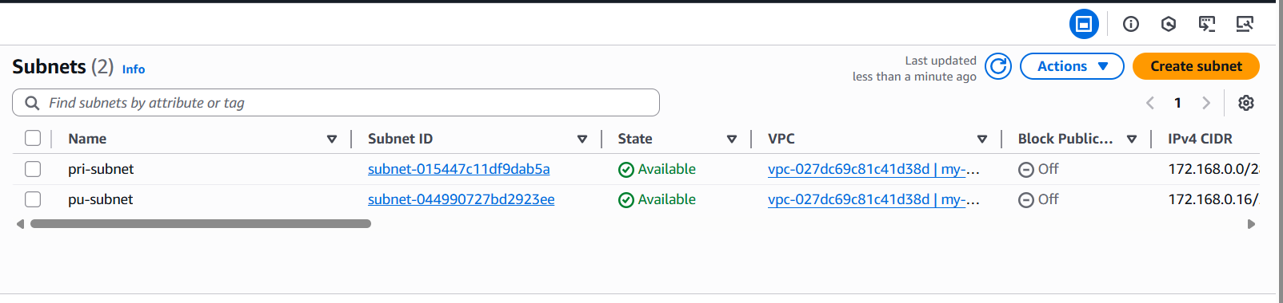

- Enable VPC peering for cross-region.
- Navigate to peering connections and create peering connection
- Give connection name
- Note: - for this you need to create two vpc in two different region
- Select your vpc to which you are providing the opeering connection
- Select the vpc to connect from one region to other
- Provide the vpc id you want to connect
- The request to the other region from one region is sent, accept the request the peering connection is set
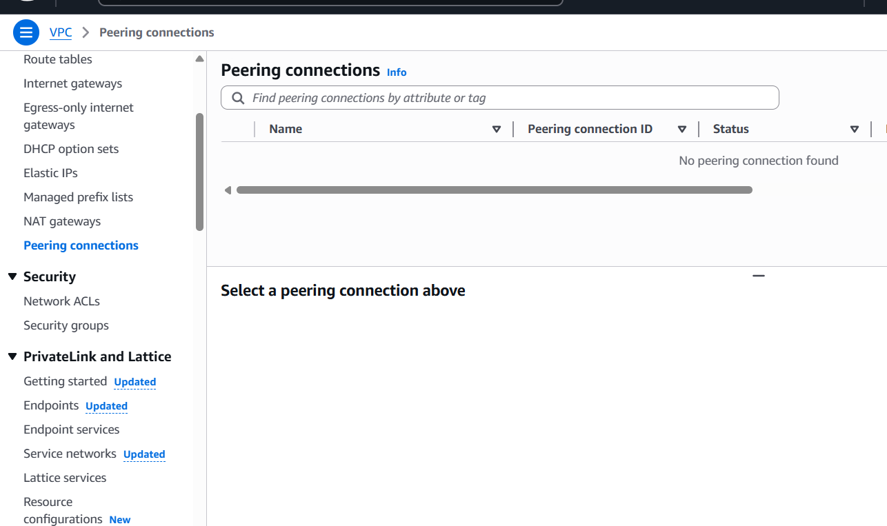
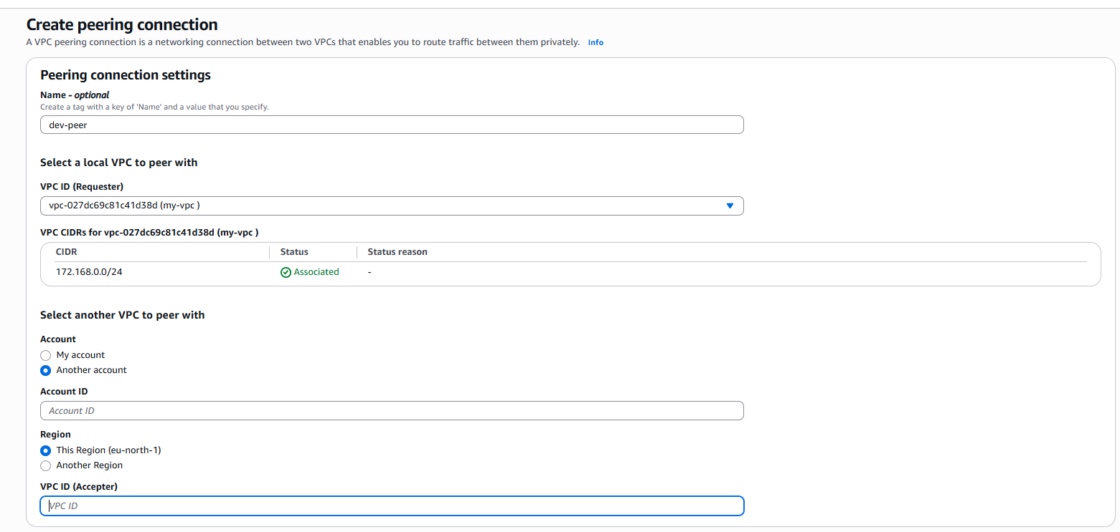
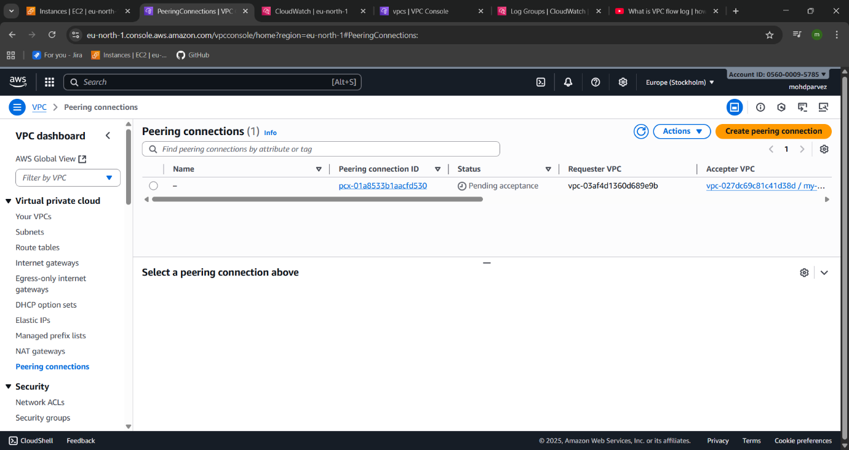
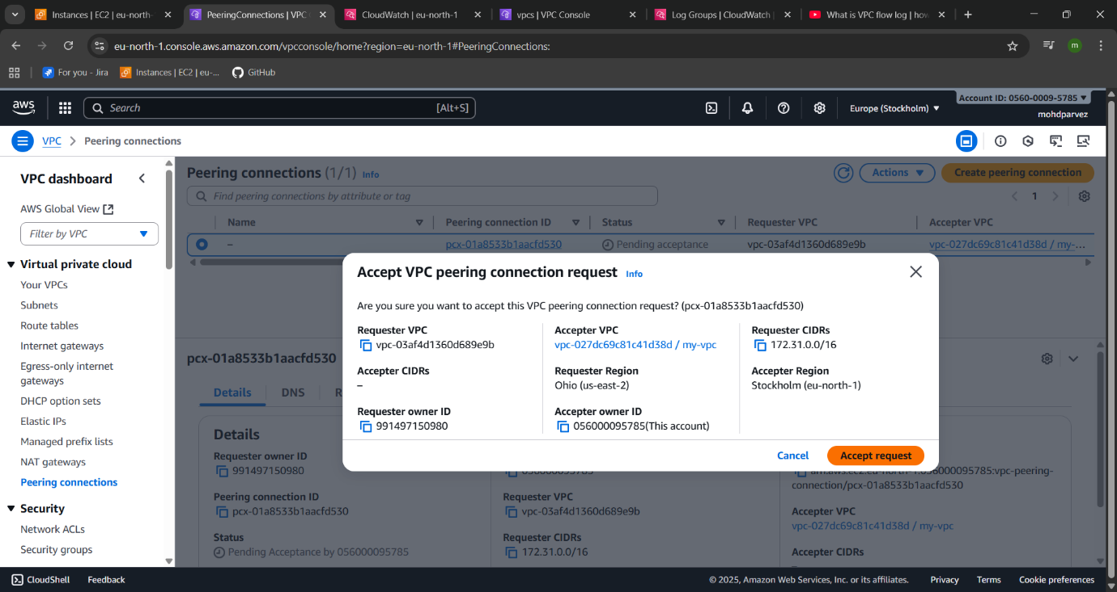


- Enable VPC peering for cross-account (you can collaborate with your friend to do this task).
- For this follow the similar steps for peering cross region
- Change the peering to another account and and give the account id of the other user
- Also provide the vpc id to send the peering request from one account to the other account user
- The account accept the peering request the peering connection is set.
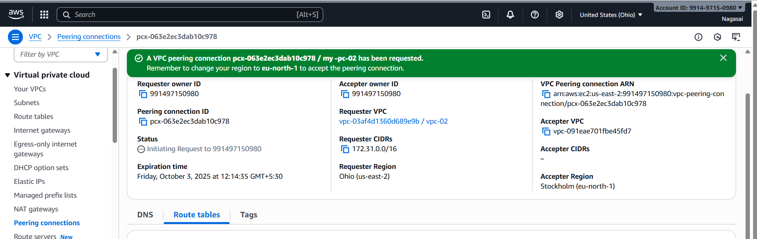
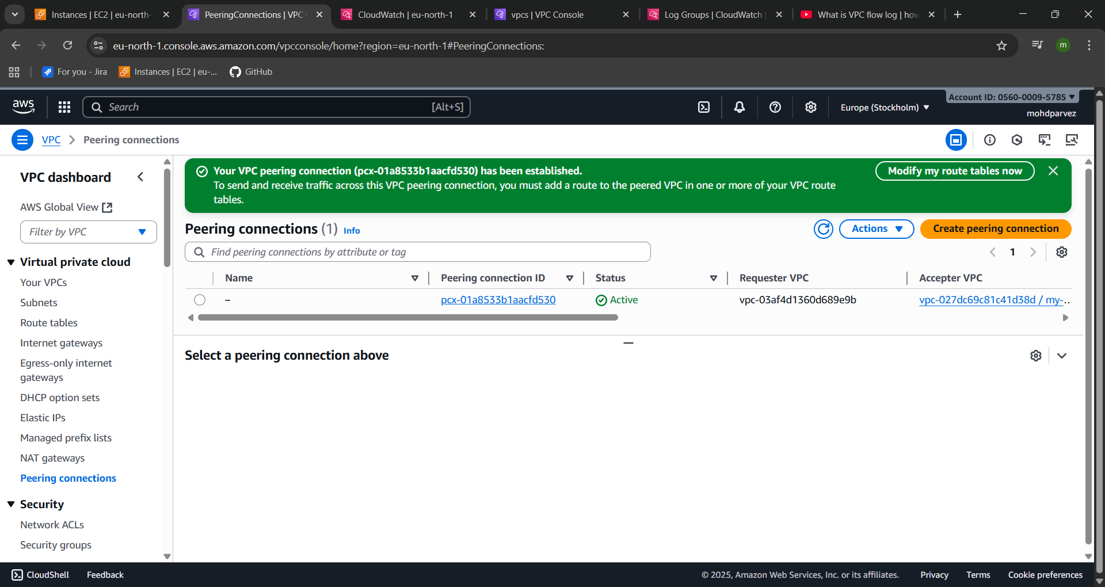

- Set up a VPC Transit Gateway.
- Create three vpc with one for public and two for the private
1) 172.168.0.0/24
Cidr range of 3 vpc’s created
2)10.0.1.0/28
3) 10.0.0.0/28
- Create the subnets to the vpc’s created
- Go to transit gate way create one transit gateway
- Then create transit gateway atachments to the vpc’s
- Then launch three instances with three vpc’s
- No connect to the vpc 1 with the public ip in CLI i.e git bash
- Then ping the private ip of the other two instances
- Attach the transit gateway to the public vpc of two other vpc cidr range created so that whwever try to connect to the vpc try to send to particular transit gateway.
- Do the same to the other vpc attach the vpc cidr range of other vpc –target transit gateway
- Create IGW (internet gate way and for vpc and attach to the routes
- If it not connecting go to ec2 – security group – add port no all traffic –then you can see coneection is established to private ec 2 created in CLI
- Use: ping <ip address private>

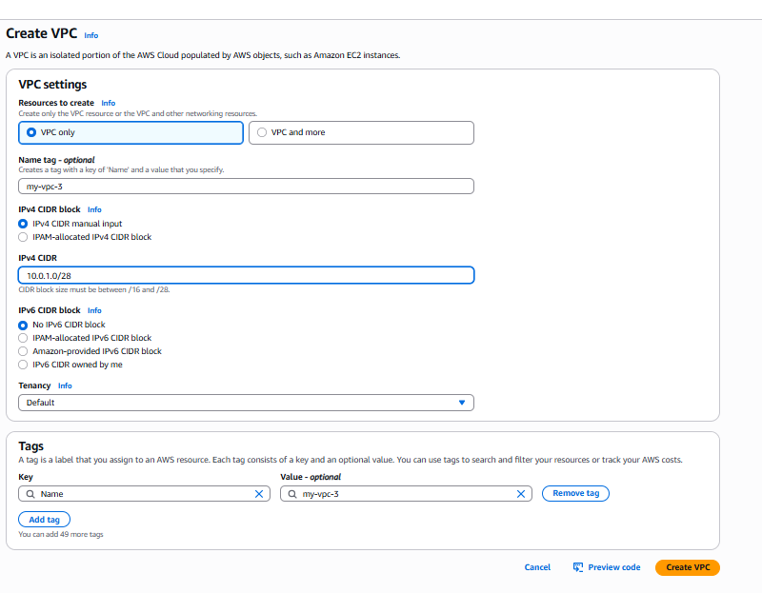
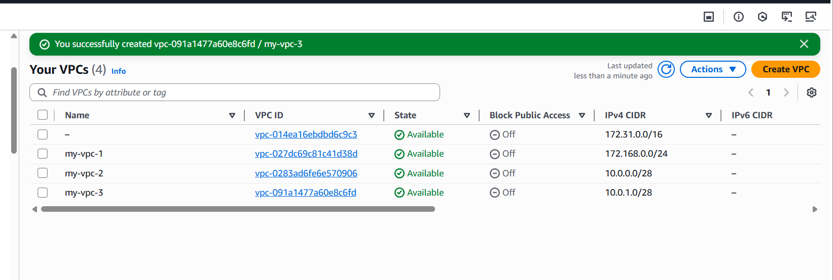
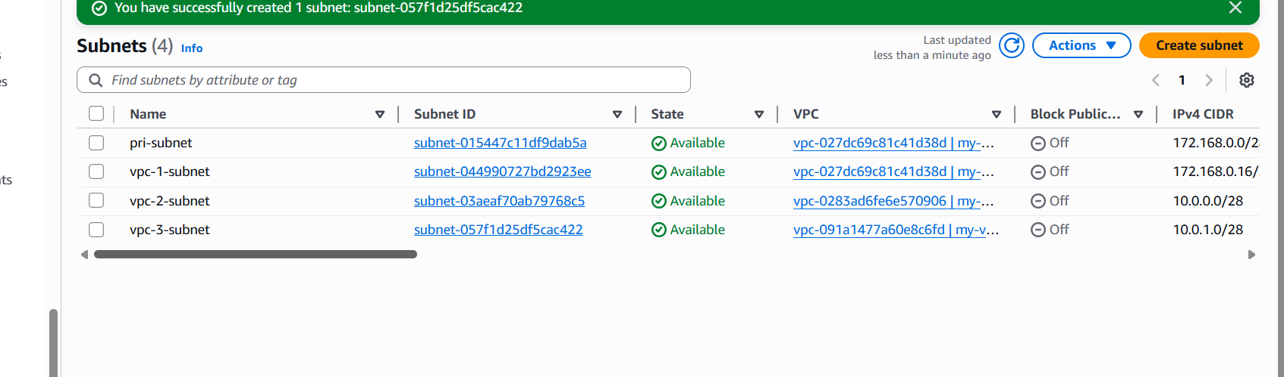
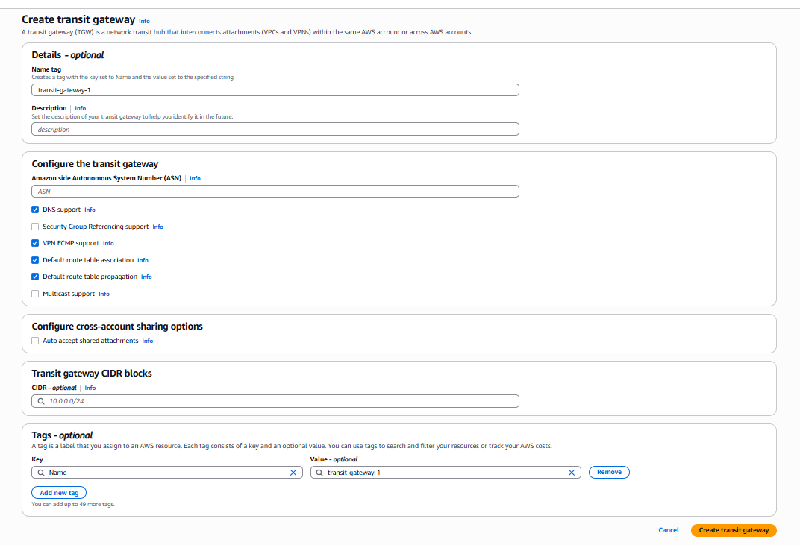
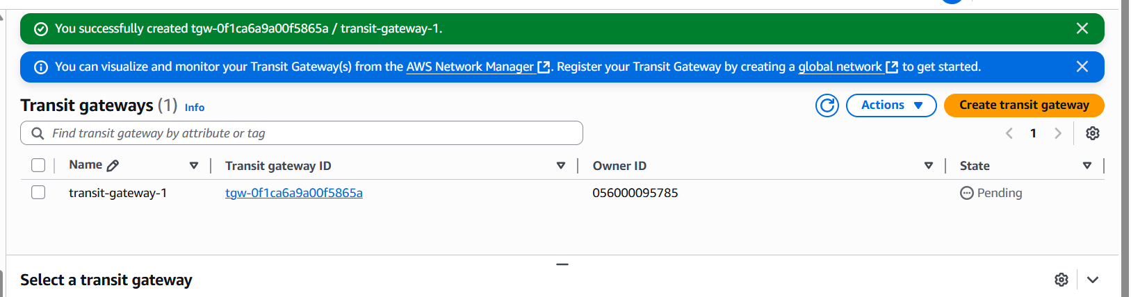
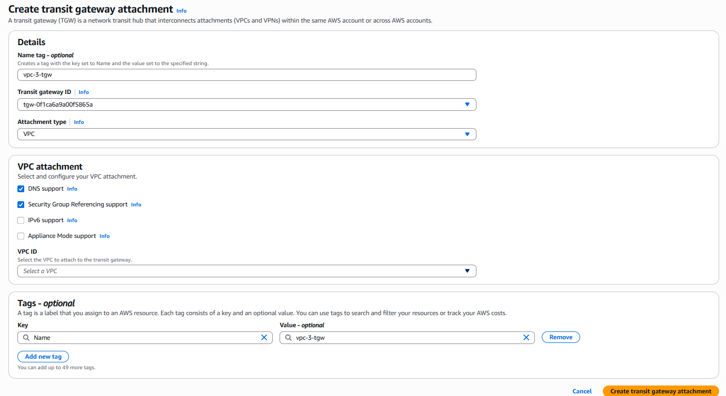
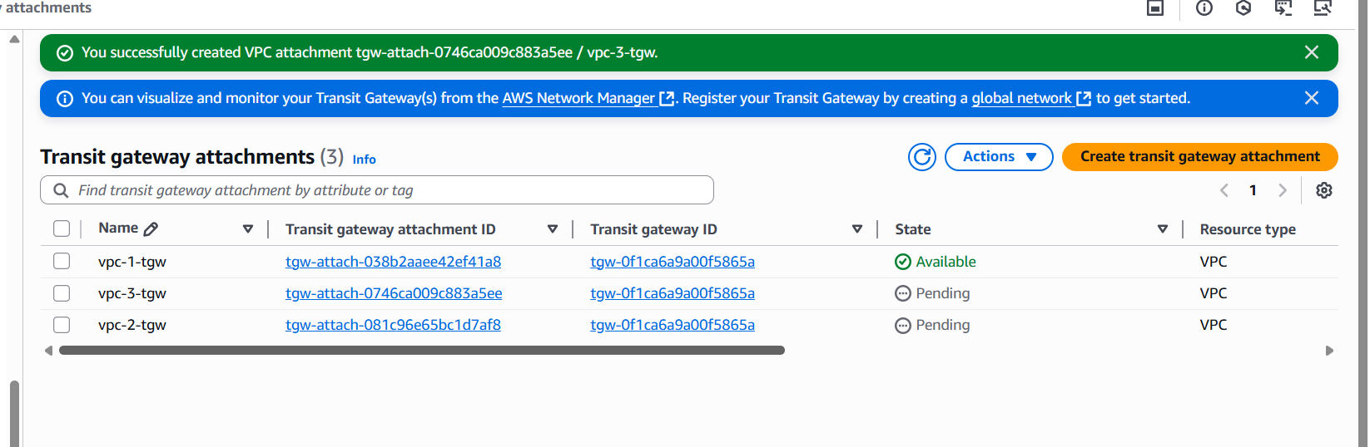
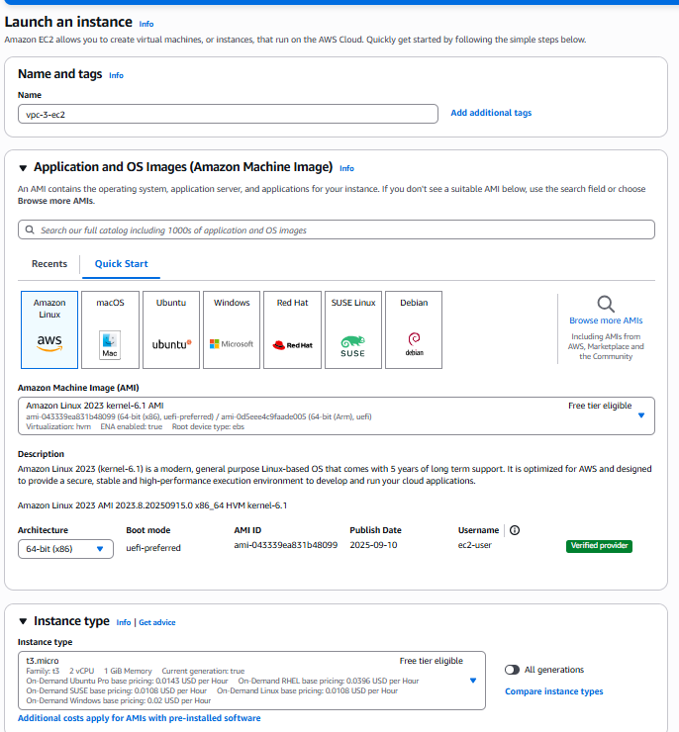
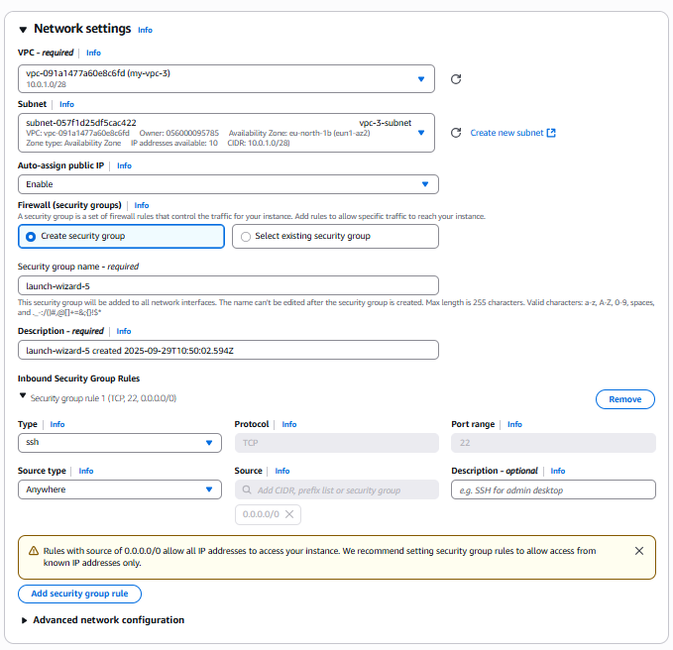
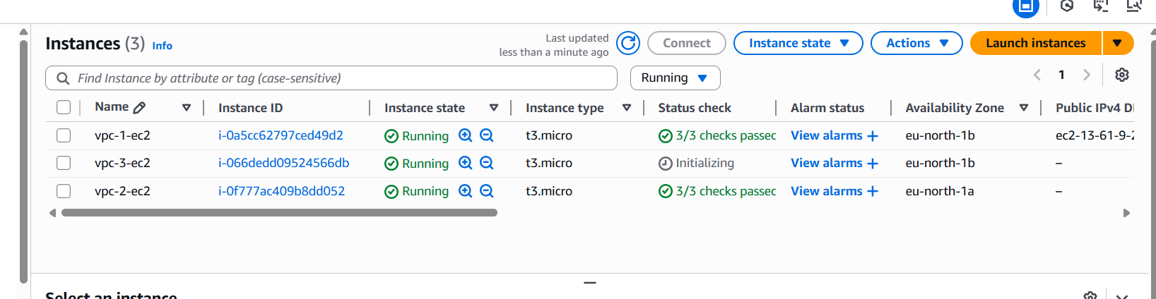
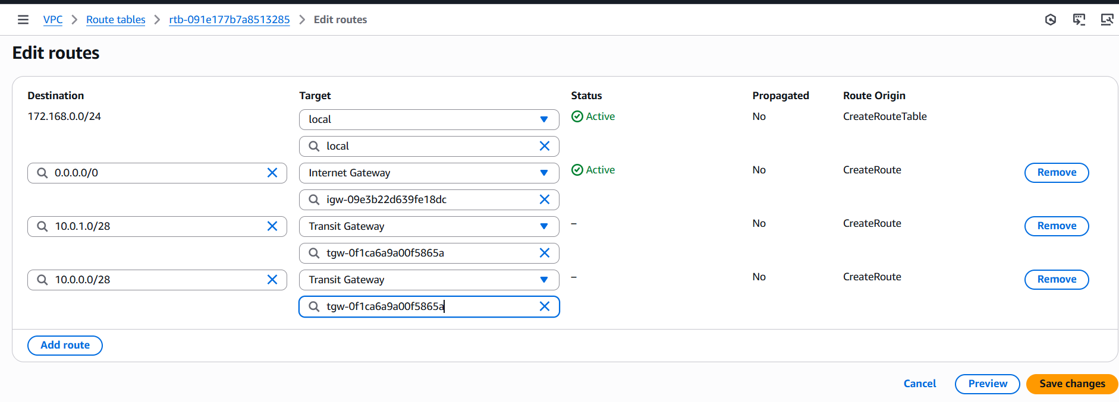
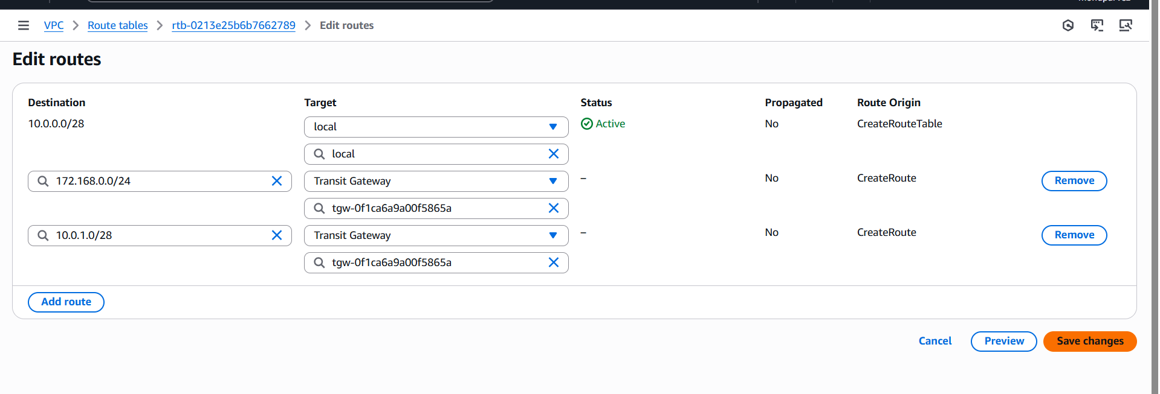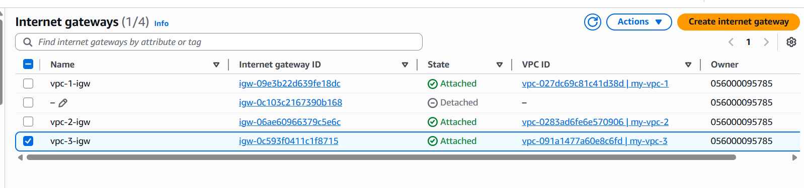
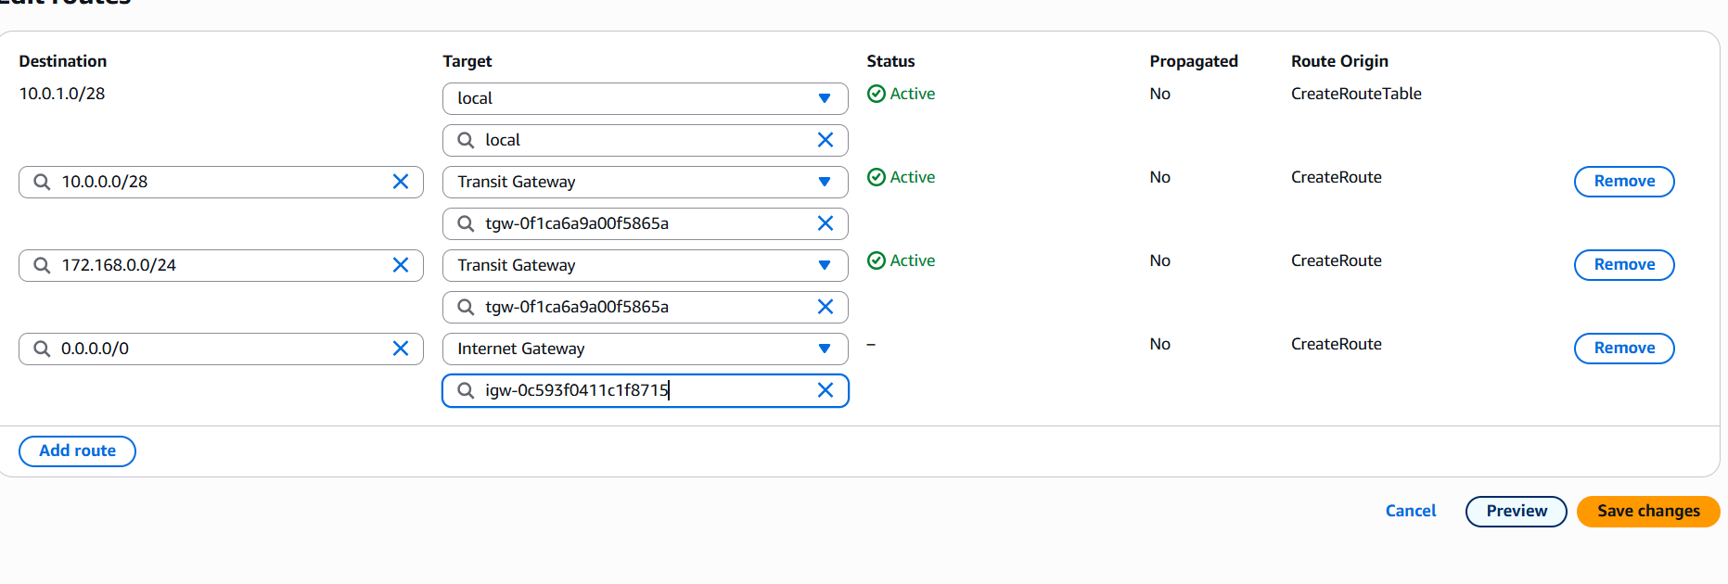
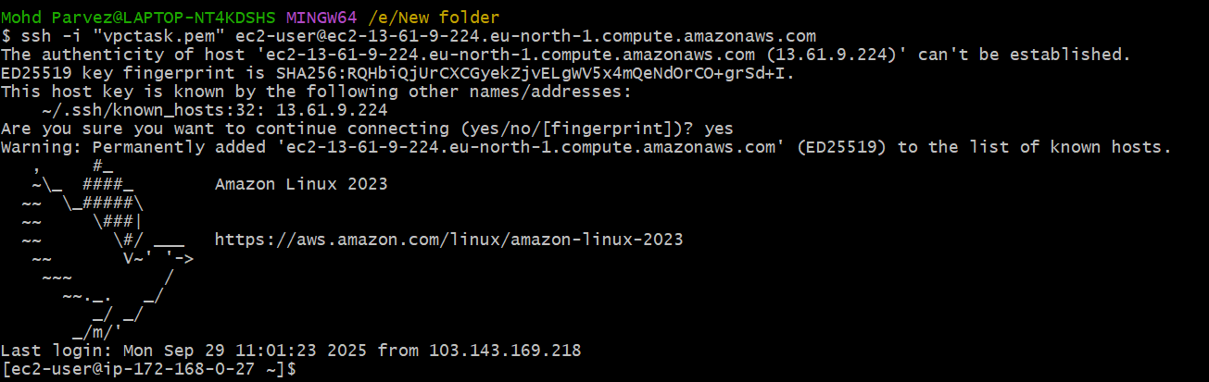
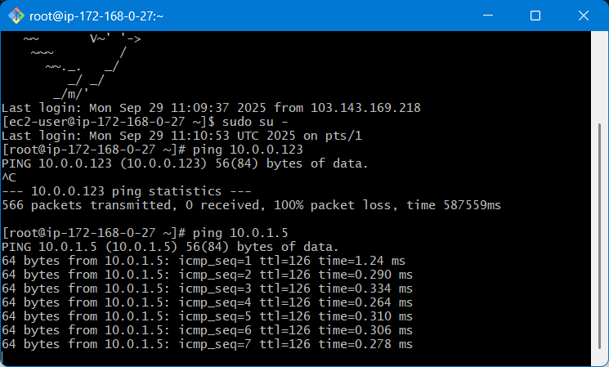
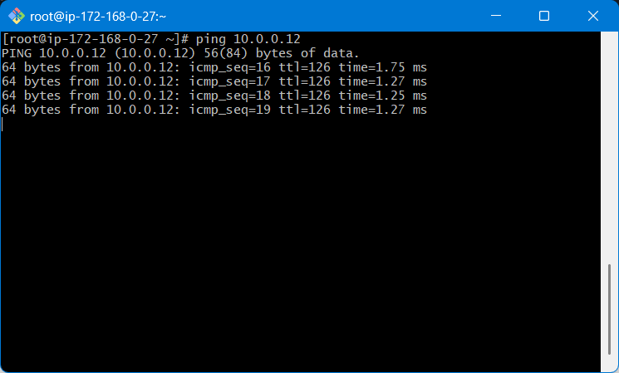
The transit gate way for the 3 vpc has benn done.

- Set up a VPC Endpoint.
- Lauch one public and private ec2 instance using private subnet and public subnet
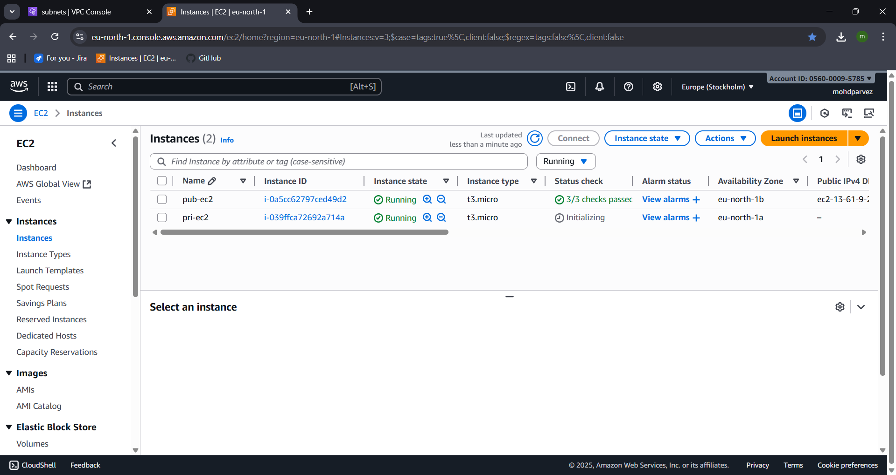
- Create one s3 bucket
- Go to s3 service
- Create s3 bucket the name of the bucket should be unique

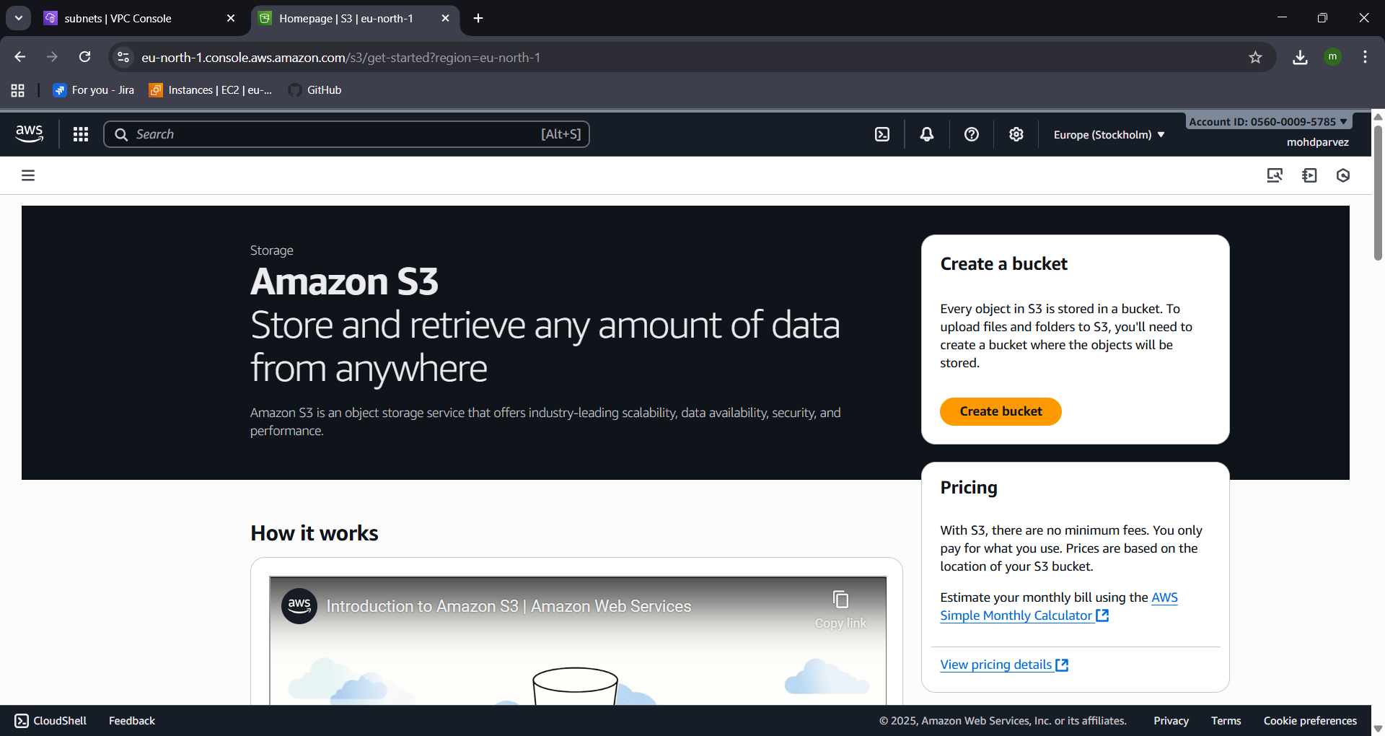
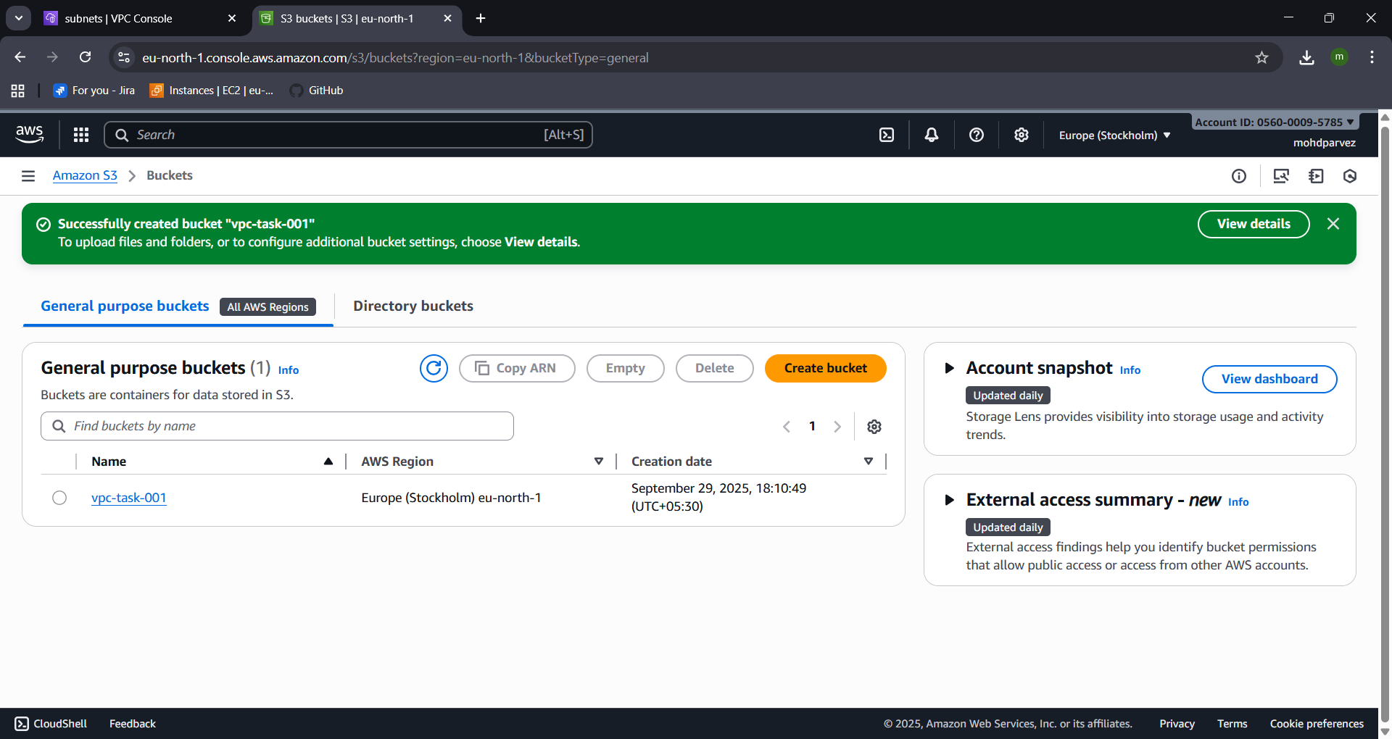
- Now connect to public ec2
- Use git bash
- Use ssh command to connect
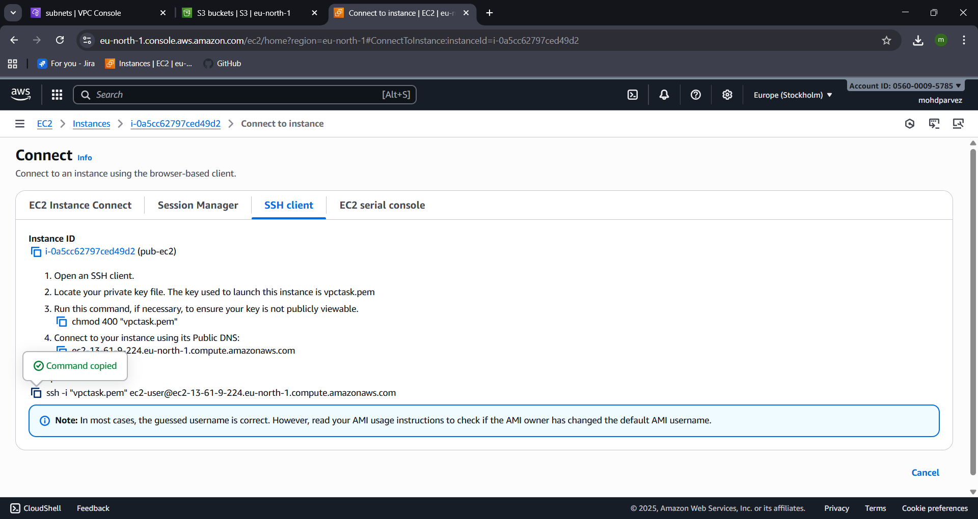

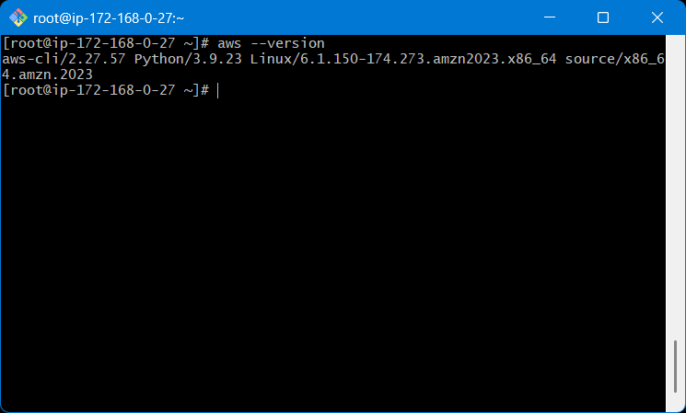
- Use aws configure : programmatic acess
- Provide acess key and secret key to configure
- Don’t have that then create in security crenditials by searching it then find create key there you can create the key
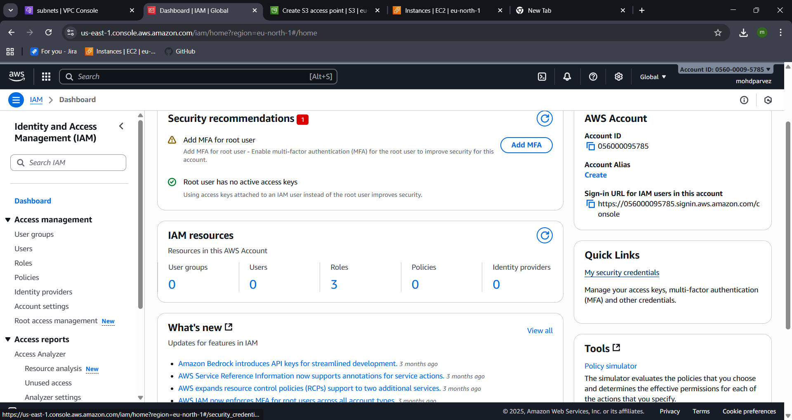
- Provide the details select the output format and region
- Use : aws s3 ls , you can see that you can acess the s3 bucket in cli
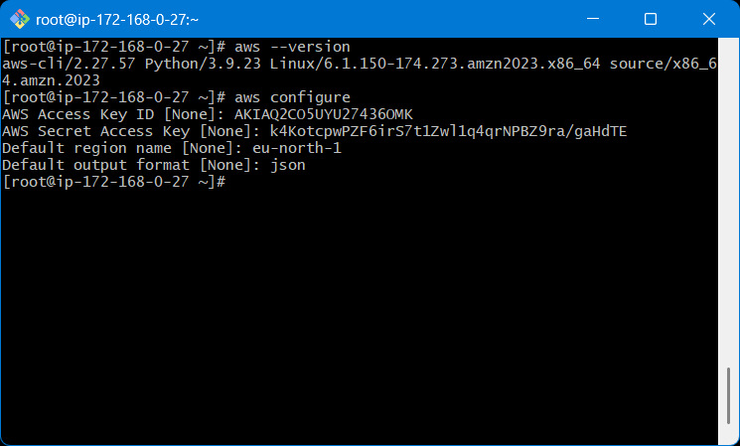
- Copy the pem key from local use cat to see the key
- Then create the pem key file and give permission: chmod 400 filename.pem
- Then use : ssh -i test.pem ec2-user@<privateip
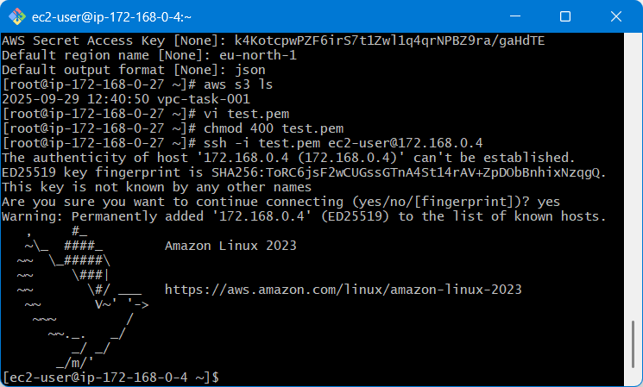
- After connecting to the private ec2
- Use aws configure and configure access key and secret key
- Select output format and region
- Now go to vpc
- Navigate to end points
- Select aws service
- Then select s3 and end point type expres
- Then select gateway
- Create end point the end point has been created
- Now you can acess the s3 from the private instance : aws s3 ls
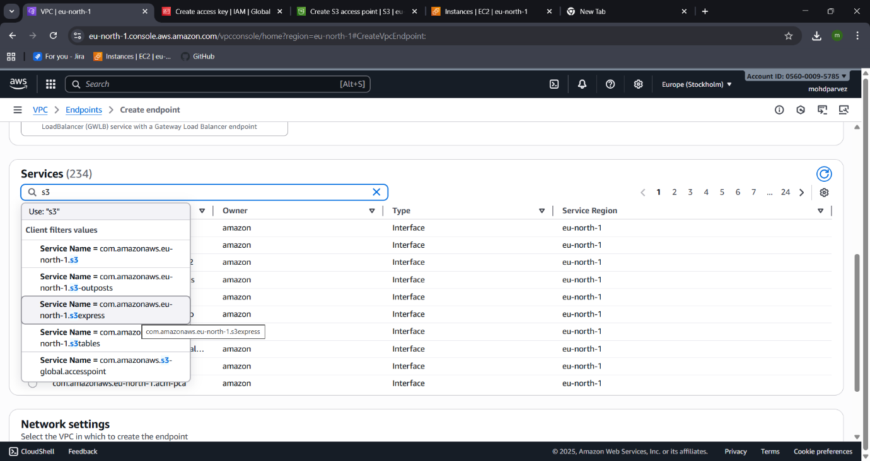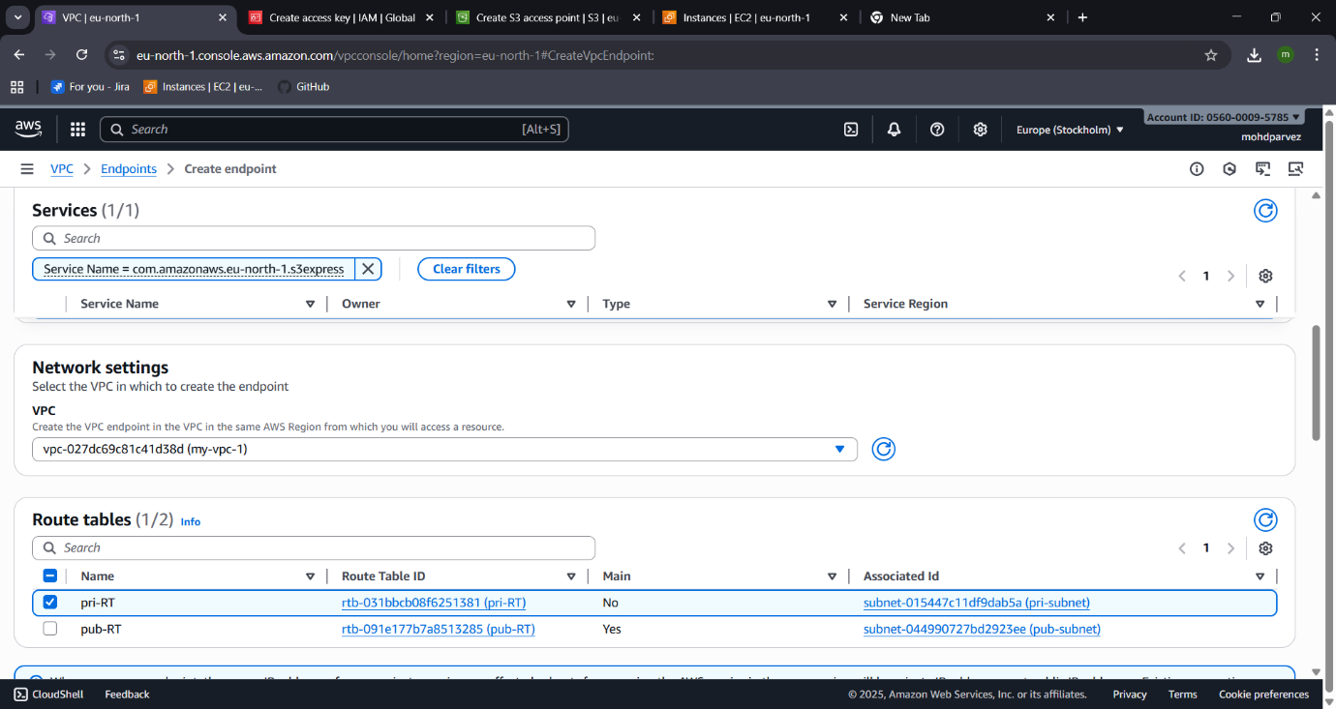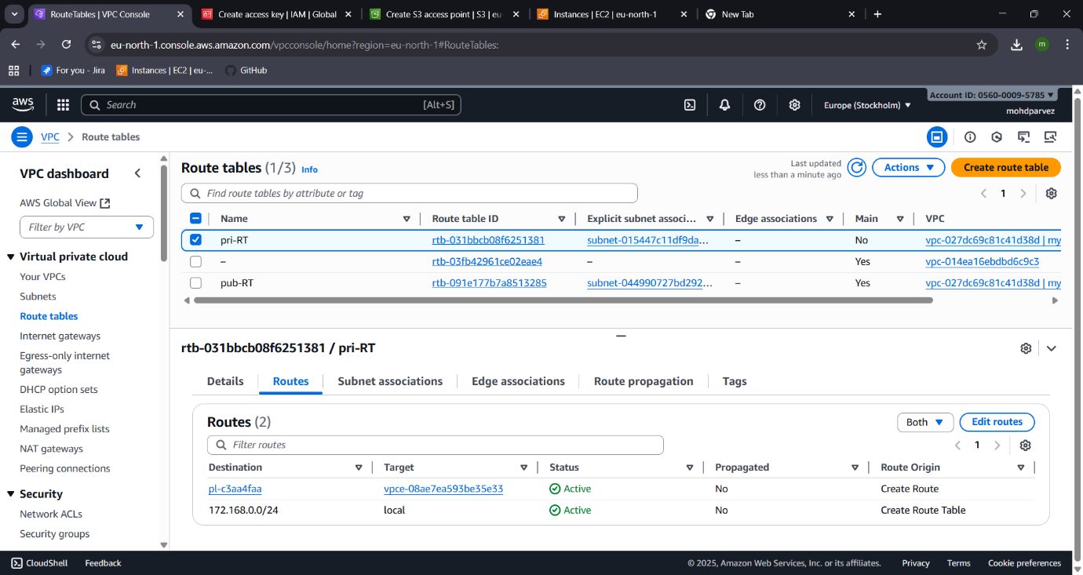
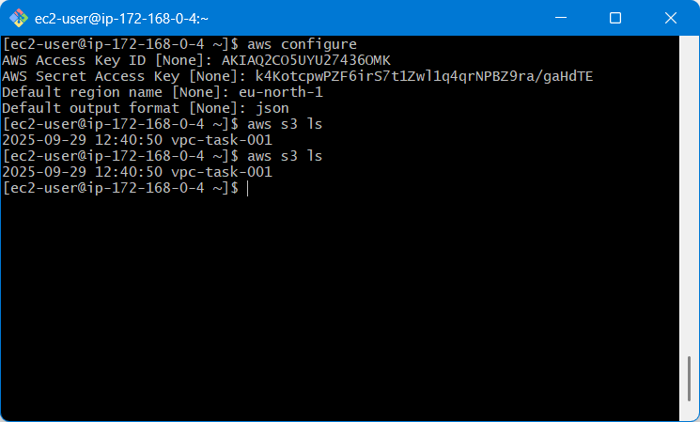
- You can see the s3 is a end point is set

